Salzburg/Austria, February, 2023
Manfred Magnus is succeeded by Martin Binder
HR generation change at COPA-DATA
At the turn of the year 2022/2023, Martin Binder has taken over the HR agendas of the Salzburg-based automation software manufacturer COPA-DATA. He succeeds Manfred Magnus, who had further developed HR management for over ten years.
Finding the best people, integrating them and helping to inspire them for the company in the long term was a challenge that Manfred Magnus, as Head of Human Resources at COPA-DATA, met in the best possible way.
In the ten years that Magnus has been in charge of the personnel agenda, the number of employees worldwide has doubled to more than 350. In Salzburg alone, the 90 colleagues have become 200. Apart from departures due to retirement, staff turnover has been virtually zero.

Growth based on solid structures
When the Head of HR himself retires now, he hands over well-developed structures to his successor and thus the best basis for future growth. "The labor market for more qualified people has become more competitive on an ongoing basis, while at the same time employees' expectations in terms of development opportunities and flexibility have risen," says Magnus, reflecting on the developments of recent years. "Finding the perfect balance has been a constant challenge." The legal framework was also becoming more complex instead of simpler, as repeatedly announced. The necessary response speed and quality could have increased in many ways.
Social media offered and still offers additional new opportunities in recruiting and employer branding. Magnus found support in a very good environment and a very positive attitude on the part of the owner and management.

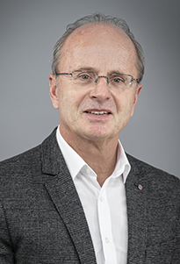
As head of the HR department, Manfred Magnus succeeded in keeping staff turnover close to zero despite rapid growth.
Different needs require flexibility
With Martin Binder, an experienced HR expert now takes the helm. After a business-oriented school education (commercial high school), he completed a degree in law and worked for more than 20 years as a senior HR manager and lawyer at leading Austrian industrial companies, most notably at Palfinger, world market leader for cranes and at Hawle, an internationally active manufacturer of large valves for water pipes.
Like his predecessor, Binder reports directly to the company's founder and CEO Thomas Punzenberger. Binder wants to further develop those framework conditions that will further sharpen COPA-DATA's position as a pioneer in terms of flexibility and employee orientation.
In doing so, it is important to meet the different requirements of young singles, parents and senior experts in equal measure. To this end, it is essential to enable creative and flexible employment models, according to Binder. The international orientation alone makes this necessary.

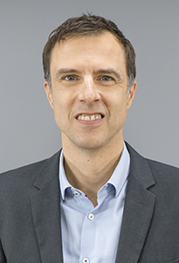
As COPA-DATA's new Head of Human Resources, Martin Binder focuses on flexibility and open communication in order to attract employees and inspire them in the long term.
Sustainability as a decision criterion
Binder sees the fact that the in-house software also makes an important contribution to the energy transition as an additional advantage in the competition for the best minds. "It is particularly important for the younger generations to be able to engage in meaningful activities even during working hours." Value-based actions and an honest, open communication culture on the part of the company's management are a matter of course for attracting and retaining employees in the long term.

Open positions at COPA-DATA
Downloads:
Manfred_Magnus_portrait.jpg
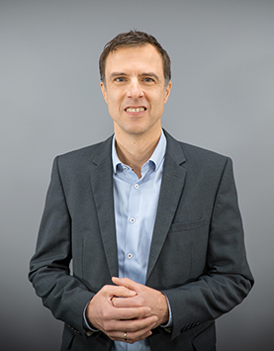
Martin_Binder_portrait.jpg, Martin_Binder_portrait_2.jpg

About COPA-DATA
COPA-DATA is an independent software manufacturer that specializes in digitalization for the manufacturing industry and energy sector. Its zenon® software platform enables users worldwide to automate, manage, monitor, integrate and optimize machines, equipment, buildings and power grids. COPA-DATA combines decades of experience in automation with the potential of digital transformation. In this way, the company supports its customers to achieve their objectives more easily, faster and more efficiently.
The family-owned business was founded by Thomas Punzenberger in 1987 in Salzburg, Austria. In 2021, with more than 350 employees worldwide, it generated revenue of EUR 64 million.
Your contact persons:
Robert Korec
PR & Communications Consultant
+43 662 43 10 02 – 296
Robert.Korec@copadata.com

Sebastian Bäsken
Marketing Communications Manager
+43 662 43 10 02 – 345
Sebastian.Baesken@copadata.com

Ing. Punzenberger COPA-DATA GmbH
Karolingerstr. 7b
5020 Salzburg, Austria
www.copadata.com

